***Configuring TIBCO Spotfire with DSIS data sources***

**Connecting spotfire to DSIS data sources**

Steps below must be performed on the spotfire server to access DSIS data sources from spotfire’s information designer.

1. Copy teiid driver jar file(available in the zip file) into spotfire server at the following location : C:\tibco\tss\7.6.0\tomcat\lib

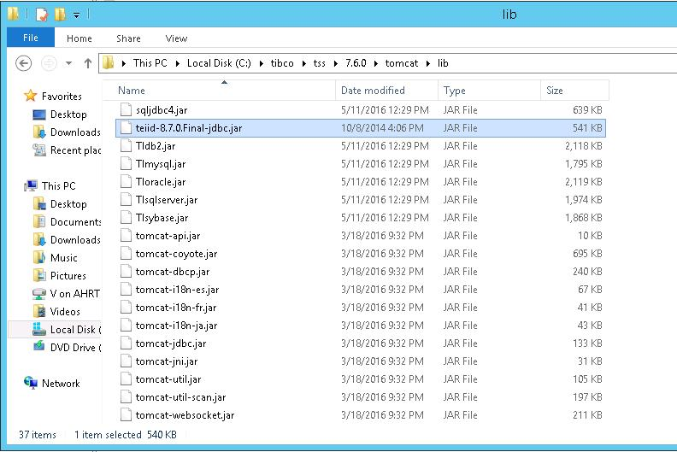

1. Open spotfire configuration tool**→**navigate to configuration section and click on Data Source Templates

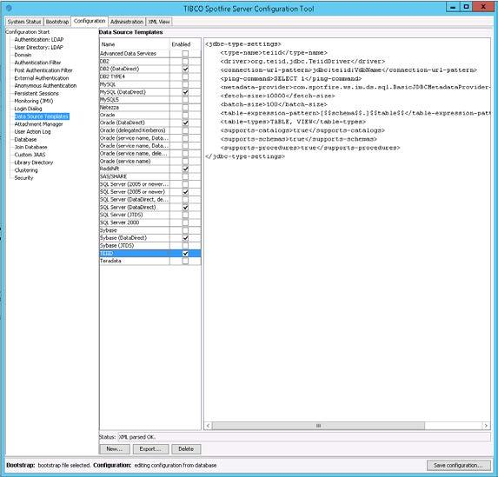

December 2016

1. Click on New to add a new JDBC data source template : provide a name (Teiid or DSIS VDB) and copy the following content into the Data Source Template section

*<jdbc-type-settings> <type-name>teiid</type-name> <driver>org.teiid.jdbc.TeiidDriver</driver>*

*<connection-url-pattern>jdbc:teiid:VdbName</connection-url-pattern> <ping-command>SELECT 1</ping-command> <metadata-provider>com.spotfire.ws.im.ds.sql.BasicJDBCMetadataProvider</metadata-provider>*

*<fetch-size>10000</fetch-size> <batch-size>100</batch-size>*

*<table-expression-pattern>[$$schema$$.]$$table$$</table-expression-pattern> <table-types>TABLE, VIEW</table-types> <supports-catalogs>true</supports-catalogs> <supports-schemas>true</supports-schemas> <supports-procedures>true</supports-procedures>*

*</jdbc-type-settings>*

1. Ensure the Status message at the bottom reads *XML Parsed OK.*
2. Save the configuration and restart the spotfire server/service to load the changes made to the configuration
3. From spotfire Analyst, launch Information Designer and setup a new Data Source. Select the newly created data source name and provide the URL to the DSIS vdb

Name : Name of the Connection

Type : TEIID (It should be the above configuration we created)

Connection URL : Your DSDS JDBC URL.

Ex. jdbc:teiid:KwIDF@mm://AHDEVSRV01.AHNAO.PRI:31000;version=1

Credentials:

Provide the DSDS User ID and Password

Uncheck the “User Authentication”

Once you provided all the information, Please save the Data connection.

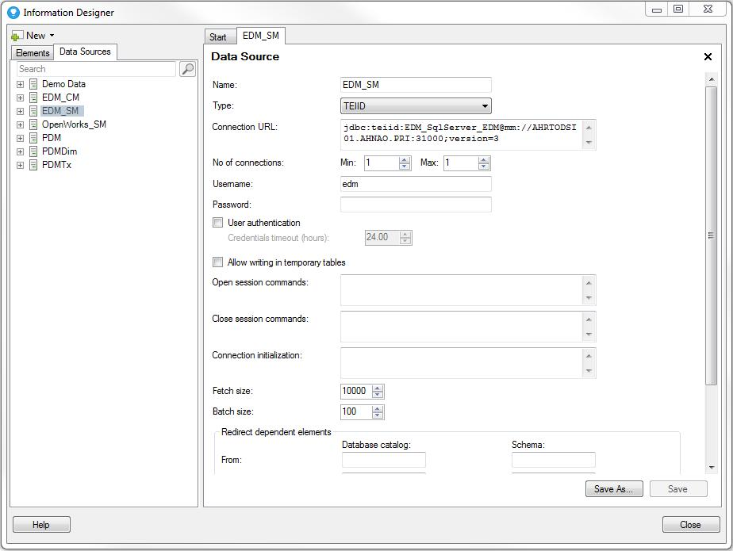

1. Once you created the Data source, your data source will be available in the “Data Source” tab in the information Designer.

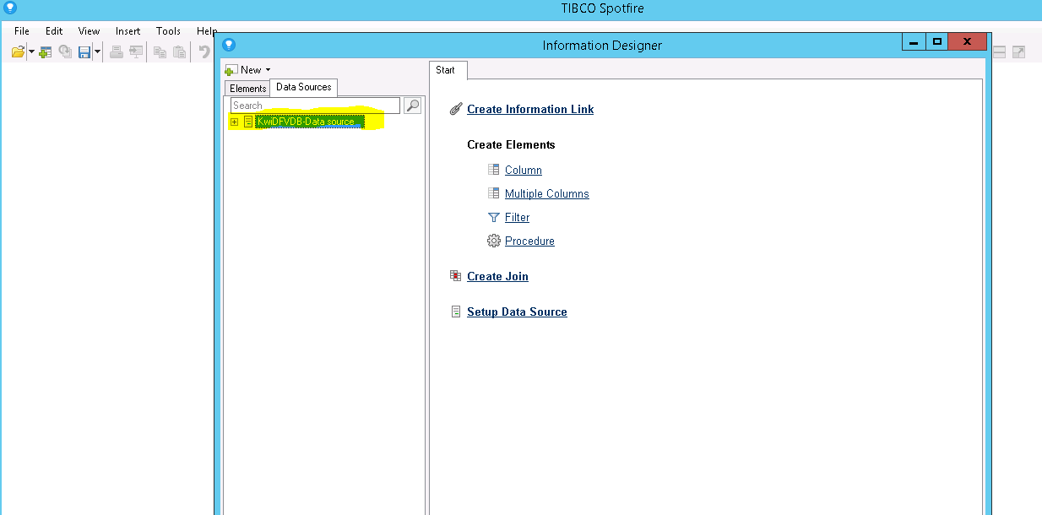

1. Create an Information Model.

Once we created a data source, we have to create a Information model using the steps given below.

1. In the Information Designer, please right click on the Data source and click “Default Information Model” menu.

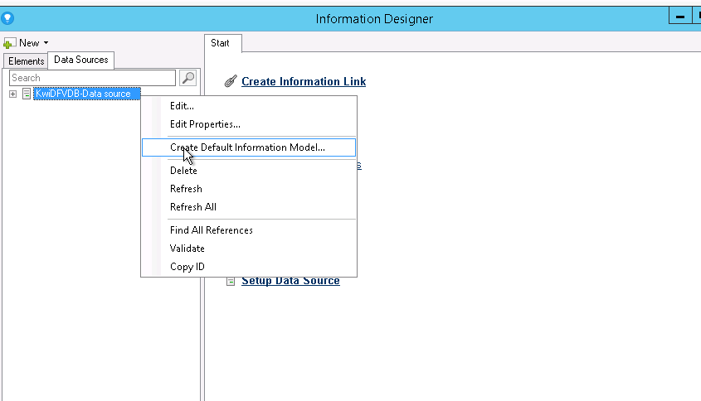

1. Select the destination folder and Click OK.
   1. Note: When you select the folder, you have to consider about the permission for the folder. The Permission for the DXP folder and this folder should sync. Then only the user can access the Information link from the DXP.

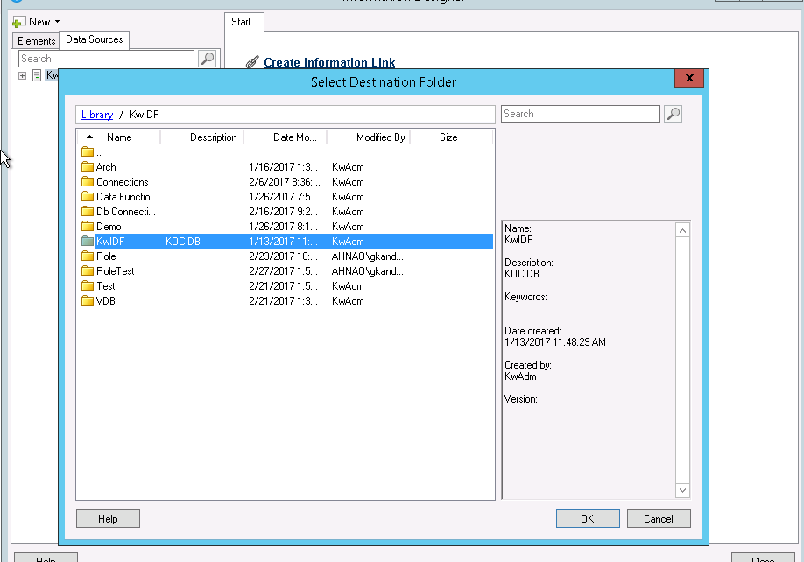

1. Replace the SQL server connection with the VDB views (information link)

Open the DXP in the Analytics and Navigate to File🡪 Replace Data Table

Select the Data Table to replace as the SQL View / Table we need to replace.

Select the Source to Replace with “Information Link”

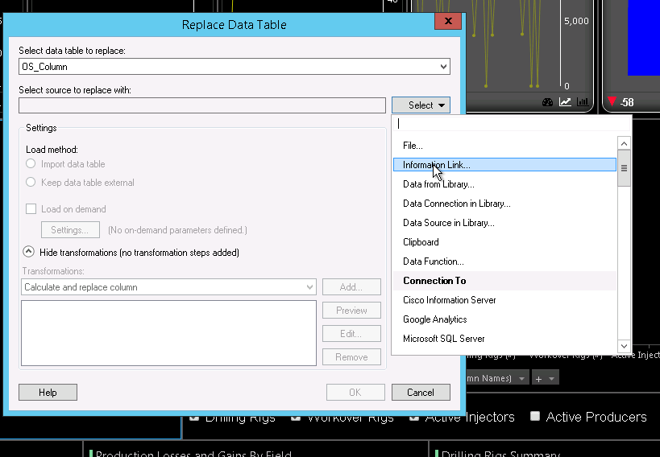

Browse to the folder where we created the “Default Information model” and select the respected Information link.

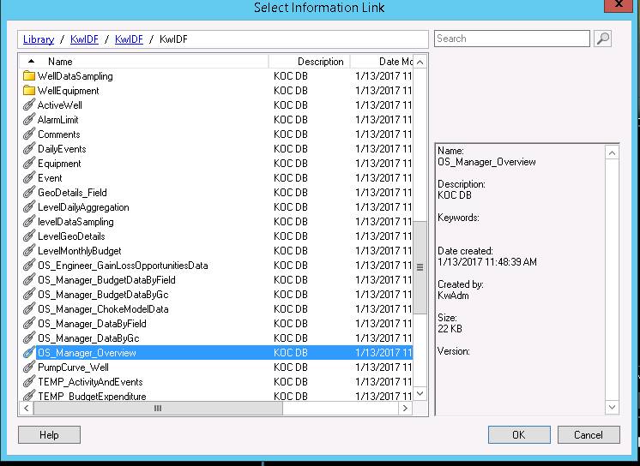

Repet the above replace procedures for all the SQL views you want to replace.

1. Once you replaced all the SQL view, please delete all the connections available under

Edit🡪 Data Connection Properties . Once you deleted, it should be as like this.

